Preliminary Requirement Study Result

**Questionnaire Result**

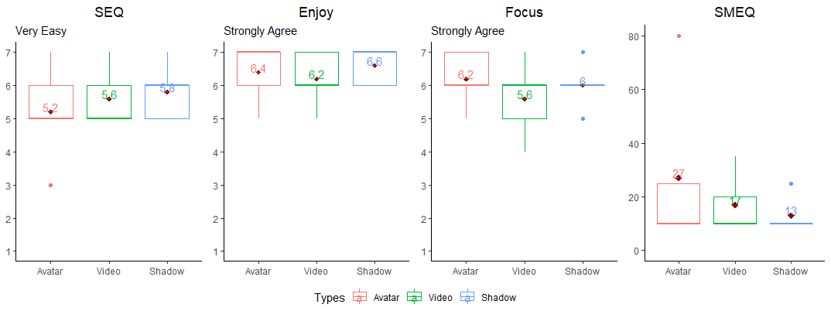

Overall, three out of five participants prefer condition Shadow, and the rest prefers condition Avatar.

The participants rated the Shadow condition (*M = 5.8, SD= 0.836*), as the easiest among the conditions follow by Video (*M = 5.6, SD= 0.8944*) and Avatar (*M = 5.2, SD= 1.4832*) respectively.

In term of enjoyment, the participants rated the Shadow condition (*M = 6.6, SD= 0.547*), as the best among the conditions follow by Avatar (*M = 6.6, SD= 0.894)* and Video (*M = 6.2, SD= 0.836)* respectively.

In term of focus, the participants rated the Avatar condition (*M = 6.2, SD= 0.836*), as the best among the conditions follow by Shadow (*M = 6.0, SD= 0.707)* and Video (*M = 5.6, SD= 1.140)* respectively.

In term of subjective mental effort, the participants required less mental effort in Shadow condition (*M = 13, SD= 6.708*), follow by Video (*M = 17, SD= 10.954)* and Avatar (*M = 27, SD= 30.33)*

In term of co-presense, the participants rated the Avatar condition (*M = 6.6, SD= 0.547*), as the best among the conditions follow by Shadow (*M = 6.067, SD= 0.829)* and Video (*M = 5.33, SD= 1.13)* respectively.

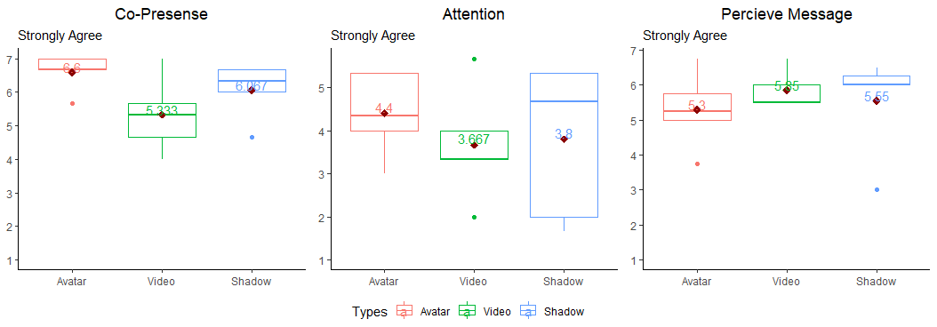In term of attention, the participants rated the Avatar condition (*M = 4.4, SD= 0.983*), as the best among the conditions follow by Shadow (*M = 3.8, SD= 1.819)* and Video (*M = 3.67, SD= 1.33)* respectively.

In term of perceive message understanding, the participants rated the Video condition (*M = 5.85, SD= 0.547*), as the best among the conditions follow by Shadow (*M = 5.55, SD= 1.44)* and Avatar (*M = 5.3, SD= 1.09)* respectively.

**Summary**

Shadow condition is better in terms of SEQ (easy), enjoyment, and subjective mental effort. Avatar condition is better in terms of focus, co-presence, and attention. Video condition is better in term of perceived message understanding

**Participants Comment**

Summary

* Most participants think that the locomotion (Teleport) can be improved or eliminated, everyone commented that if there is a larger area for walking, the task would be much easier.
* All participants have no problem moving close or go through the instructor.
* The participants who prefer Shadow condition think that direct comparison between solid and semi-transparent effect helps improve the task.
* Most participants did not confuse between semi-transparent objects and solid objects, but some participants request better distinction between two types of objects
* The participants who prefer Avatar condition think that the setup is more natural.
* Every participant thinks that Video condition is better for reading text, but not for the other tasks due to the lack of spatial references. During the Video condition, the participants mostly use 1st person perspective video.
* In Avatar condition and Video condition, participants spent a lot of time, looking for objects. Some participant suggests a way to locate an object better.
* Every participant does not have a problem with the avatar’s apearance.
* Every participant think that the system is good enough for education